End-of-Semester Project Report

MAC Scheduling on Ad-hoc Network

Zhibin Wu
WINLAB, Rutgers University
Jan. 10th 2003

1 Project Objective:

This research project is focused on the performance issue of MAC protocol in wireless ad-hoc network, when a scheduling algorithm is introduced in the MAC protocol. Currently, IEEE 802.11 series protocol is used in local wireless ad-hoc network. It’s based on a “bursty” traffic model in which scheduling is assumed not feasible under this circumstance. So, channel resource is allocated in a “random” manner upon each node’s request in the protocol, e.g. 802.11b. However, because of the heterogeneousness of the wireless link environment, which means different nodes (within its proximity) of the network probably encounter different channel state at the same time, we consider that some kind of scheduling could help to improve the overall performance (such as total channel throughput) of the network by suppressing the traffic load form node with bad channel state.. To verify and utilize this possibility, I design the new MAC protocol in which an RSSI (received signal strength indicator)-based scheduling algorithm is embedded. And I apply this protocol in actual wireless environment and do experiment to verify the performance improvement and optimize the parameters. The objective is to evaluate the potential degree of improvement when new scheduling algorithm is adopted and what set of scheduling rules should be used to achieve that. Another goal in the project is to develop new MAC protocols for forwarding nodes of our hierarchical wireless sensor network, in which AP( Access Point), FN (Forwarding Node) and SN ( sensor node) constitute a three-tier communication architecture. Under this architecture, FNs will exhibit different characteristic from the nodes in ad-hoc network. A new MAC protocol which is well poised from “totally random” nature to “strictly scheduled” mechanism is desirable.

2 Background

2.1 IEEE 802.11 MAC

The most obvious feature of a wireless link is that it’s usually a shared channel in the sense of frequency spectrum. Another important feature is that the characteristic of the wireless environment is varying and unpredictable. Both of these two features present great challenges to the task of network management. As far as to the issue of MAC (medium access control) protocol design of WLAN (Wireless Local Area Network), IEEE 802.11b is already a handy, although not perfect, solution to that. It introduces a new CSMA/CA mechanism, comparing to the CSMA/CD mechanism in Ethernet. It presents the following method to combat with the adversary wireless environment.

1. Assume that the traffic generated from/to each node is bursty, a simple “Send-ACK” scenario is used for medium access.
2. An optional RTS/CTS mechanism to avoid collision and “hidden terminal” problem.
3. A back-off procedure is used to co-ordinate simultaneous access to the channel.
4. The contention window length is dynamically changed which is partly ensured that a node with bad link quality (resulting re-transmission) is less likely to win in the contention to obtain access to the channel.
5. An optional fragmentation/defragmentation mechanism

As can be seen from above, IEEE 802.11 MAC protocol is similar to the corresponding wireline Ethernet protocol and has only a few mechanisms designed specially for the wireless environment. It’s simple to implement, but it sacrifice the performance to achieve simplicity. Basically, the wireless environment is quite different from the wired LAN. For example, in a wired LAN, signal strength is essentially binary, either on or off.
While in the wireless word, routine changes in the user can cause signal strength variations of 30dB and more. Thus, given a MAC algorithm including some consideration of some real parameters of wireless environment, there must be some room for achieve better performance.

One of the very specific problems dealt in this project is relating to packet scheduling in ad-hoc network. There is a phenomenon in current IEEE 802.11 network. When a node in the network has bad link quality (channel state, or SNR etc.), the performance of other nodes with good link quality also drop, thereby degrading overall performance. This is because the request for transmission from “relatively bad” node is unfortunately increased significantly, not decrease as we hopefully expect, due to packet loss and retransmission requirements. Thus, the chances for collision or the time used to avoid collision (when RTS/CTS mechanism is present) are also increased. So, the overall channel throughput will be affected. Packet scheduling will be an effective way to handle this problem although the complexity of MAC algorithm is increased.

2.2 Scheduling

Scheduling is not a new issue in communication networks. It is already widely applied in wire-line communication networks. A simple understanding about schedule is to arrange resources upon requests, especially when both “resource and request” remain unchanged. However, in communication, especially wireless communication, resources and requests are dynamically changed. Thus, generally speaking, “scheduling” is a prediction-based time allocation algorithm which has an optimization goal to achieve. As schedule is an arrangement for the future, it must have some sense of prediction based on current and past information because future is “always” uncertain. And there must be some ultimate goal to evaluate the effectiveness of the scheduling algorithm.

Especially in wireless communication environment, we have following challenges to design a good scheduling algorithm:
- Global information is usually unavailable in local stations in a distributed computing environment.
- Nonlinear variations of wireless links make predictions inaccurate although there are some mathematic models such as Markov model existing as an approximation.
- Multiple goals: Channel throughput, Time delay, Power Consumption and Fairness. Those factors are generate different constrains to the algorithm.

Thus, a scheduling algorithm manage wireless radio resource should face all above challenges, in addition to be at least converging and robustness.

3 Prior Work:

Since 1996, many scholars have researched on wireless packet scheduling. Some use channel state to describe the link parameters, some use SNR (signal to noise ratio). However, all those work and papers yield results based on simulation, not real networking test. It is still uncertain how the packet scheduling algorithm’s effectiveness in real WLAN environment because simulation tools usually lack of the capability to simulate real fading multi-path channels of the real world.

4 Methodology

There are two steps in my research projects. The first is to test packet scheduling algorithm with experiment. The second phase is to find and design appropriate TDMA-alike self-organized scheduling algorithm for MAC protocols of forwarding nodes. Currently, I only implement the first experiment phase.
To design a simple scheduling algorithm, I use following as the three key characteristics of the new way for MAC scheduling:
- I use the only target “channel throughput” as the variable to evaluate the performance of the scheduling algorithm.
- The information needed to make scheduling decisions are two factors. Packet length” and RSSI value (received signal strength indicator). A long packet with relatively low signal strength has a high probability of transmission failure.
- Time allocation is the simplest method: discarding. So no time slot is to be arranged for this packet.

4.1 Experiment Design:

All the testing nodes are working with 802.11b and in ad-hoc mode. All the testing nodes are sharing one same channel. Test scheme: One mastering node and 2-3 slave nodes. Only one-way communication: Slave node ----> Master node, which means slave nodes are not talking to each other. All nodes are using RTS/CTS mechanism.

4.2 Approach of the Experiment

1. Determine the throughput in good-link-quality environment
In this step, saturate the link with packets from FNs. It means maximally utilized the channel to send as more packets as possible as link quality is good. Normally, it cannot achieve 100% percent of 11Mbps, only 40%-50% percent. Then, we would know a parameter about (how many packets per second) need to maximize the throughput. In this packet rate, any more packets cannot be transferred. Moreover, it means if a packet is takes a little long time to transmit (such as re-transmission occurs). The total throughputs will be decreased immediately. "Zero-tolerance" to re-transmission.
2. See the performance degraded with the bad link-quality when BER is increasing.
I intentionally decrease the link quality of one forwarding node. By the means of " increasing the distance" and "decrease the transmit power". The goal is to let the BER dropped in an "unreliable" region.
3. See if the MAC scheduling scheme helpful to enhance throughput in abovementioned sensitive state.
Master Node
Slave Node 2
Slave Node 1

Figure 1. Test-bed Diagram

4.3. Timer and Synchronization

To correctly generate the data (packets) flow and calculate the real throughput of the channel, it is desirable to have accurate methods to handling the timing. E.g. as we prefer sends N packets per second, How do we ensure those packets are sending within 1 second.
Thus, timers are needed. This is mainly accomplished by using "signal" in Linux (refer to GNU C programming). This provides a basic method to statistical the packets transmission and reception rate.
And how to synchronize different nodes of this test-bed? A rough way is used to synchronize all testing nodes. Each slave nodes are waiting for a "START" message to begin their test-preparation. (I have to admit this "START message" is sent one by one, thereby not arriving the slave nodes at the same time.) And Master set a 1-sec timer to wait for slave's test preparation. Thus, the first timer in master node is 61-seconds. While all following timer are set as 60 seconds. (60 seconds is a basic test-period) So, after about 1s, all slaving nodes are begin to transmit, and master node is also begin to reckoning the numbers of packets received. The system is tune to that degree for nearly 1-2ms error offset (which means +/-1 packet mis-aligned for wrong test period).

4.4 Automated Test Machine

All test behaviors are coordinated through pre- and post-test coordination messages (signaling). The advantage that I need not re-set "test parameter" and re-start test
manually. At the beginning of each test, there is a negotiation period. During that period master node will inform all the slave nodes about the test to be performed, the "test-begin, test-end, and test-step, etc. such parameters.

4.5 Sockets handling

Non-blocking sockets is used for the test software. Only UDP Protocol is supported now.

5 Results

The first experiment is to show the ideal channel throughput when the link quality is good. I test with 2 scenarios, one has 1 slave node. The other one has 2 slave nodes.
The test proceeds with 60 seconds as a test period. Then the packet rate changes and test for a new test period (60 seconds). Packets are randomly generated with a random length between 0 and 1500. Channel throughput can be obtained by reckoning how many bytes received by the master node (or in an equivalent way, how many bytes are sent by the slave node).
With this method, we can predict that when packet rate is increased gradually the overall packets received by the master node will also increase linearly, until the channel is saturated by packets. Thus, the initial phase of the curve would be a monotonically increasing linear curve (corresponding to the lightly-load situation), then turning flat with heave-load.
The channel throughput can be seen from the figures below:

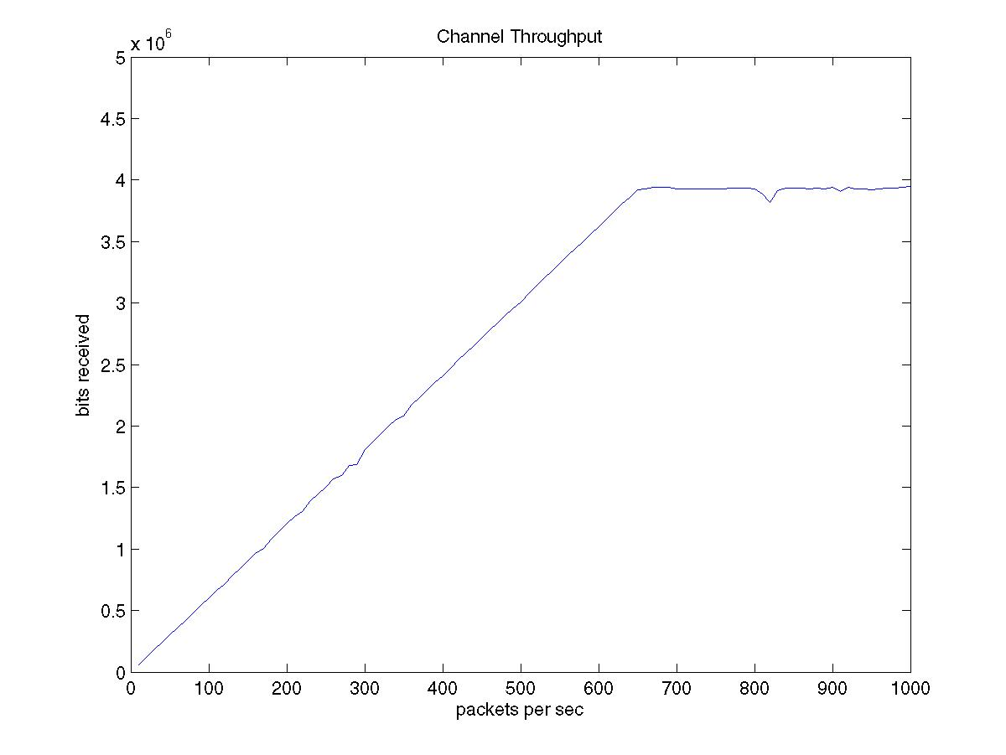
Figure 2: Channel Throughput when only one node is transmitting

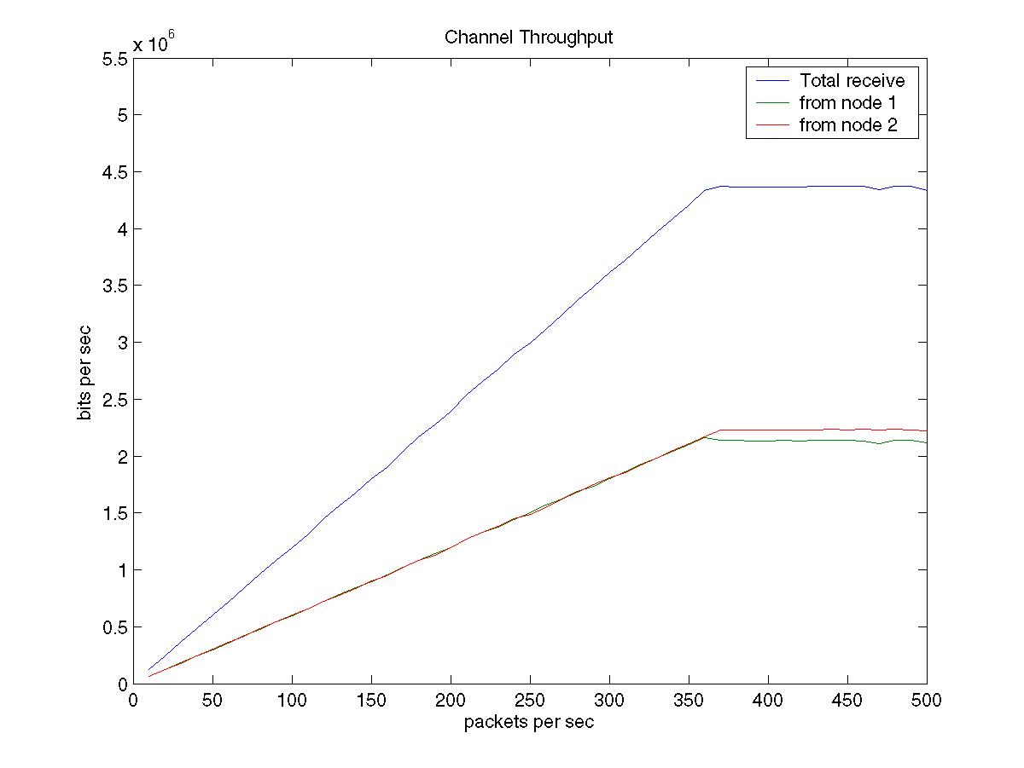
Figure 3: Channel Throughput when two nodes are transmitting simultaneously
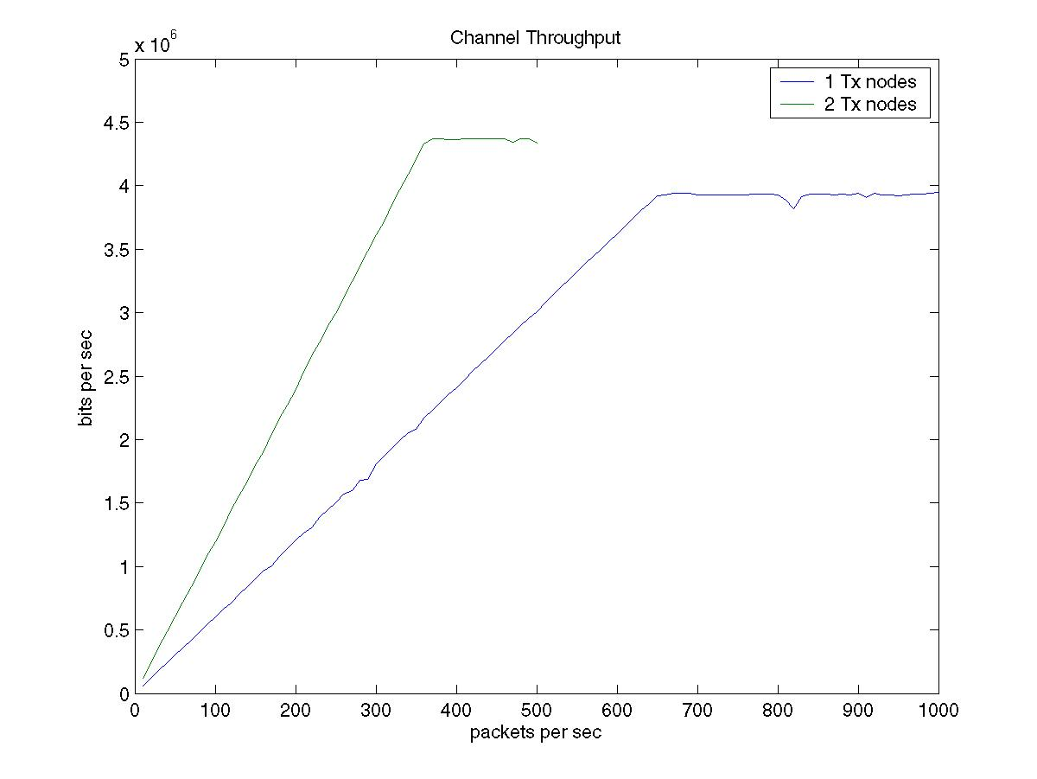
Figure 4: Channel throughput when 1-node encounter bad-link-quality

From above figures, it can be easily seen that the channel throughput (bits per second) of the test with 2 slave nodes is higher than the test using only one slave node. The explanation for this is that the WLAN card of the node’s capability (chip rate, etc) is limited so that we cannot saturate the link by only one slave node. Consider the result of the test with two slave nodes, it can be calculated that the actual channel throughput is only 4.67Mbps, approximate 40% of the upper limit (11Mbps).
The calculation method is to correct the “overhead of packet headers”. UDP header has 8 bytes. IP header cost 20 bytes. MAC header also occupies 34 bytes. Thus, the overall effect of those headers should be eliminated. The final channel throughput is:
4.3 *(750.5+20+8+34)/750.5 = 4.67 Mbps

Many factors account for the reason that why it cannot achieve the 11Mbps limit of IEEE 802.11b.
- RTS/CTS mechanism is addition cost.
- ACK frames also occupy bandwidth, but not regarded as part of channel throughput.
- Backoff procedures to contention.
- Time interval, such as SIFS, DIFS.
- Packet retransmission.

The second experiment is done with deliberately reducing the signal strength of the link for one slave node. In this experiment, there is a new phenomenon that another slave node’s channel throughput is also being affected.
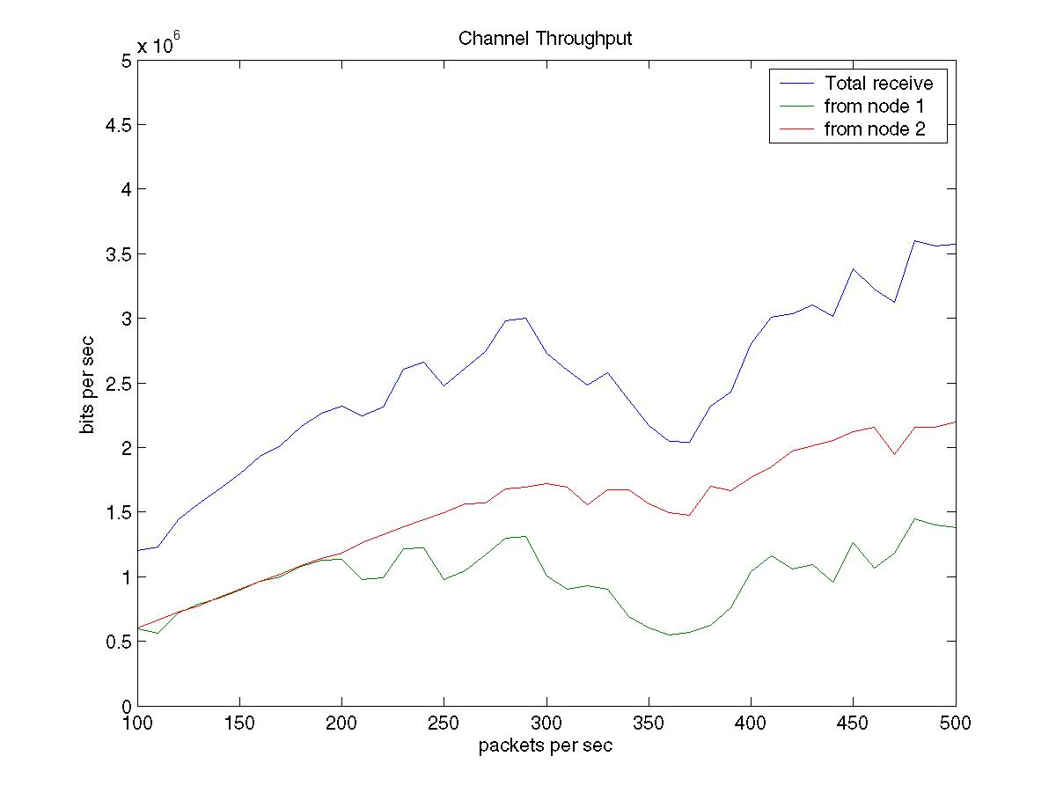
Figure 5: Channel throughput when 1-node encounter bad-link-quality

Form the figure above, it can be seen that during the test when the packet rate between 300 to 400 packets second (this amount to about 10 minutes). The link with one node is severely affected by high BER (probably due to fading effect). At the same time, bits transmitted by the other node (whose link quality remains good) is also dropping and the overall total channel throughput drops, too. This is because the node with bad link quality has to retransmission has lost packets, which waste channel resource. As we all know, IEEE 802.11b MAC protocol allows the contention of stations when a packet is not acknowledged after the time frame EIFS. Thus, the other node should have bigger chance to obtain the timeslot to transmit than the node encountering packet loss. And based on this assumption of fair competition, the node with good link quality should have equal channel throughput, or even better. However, the experiment show that, even the node with bad quality has less chance to successfully contend for the channel, its consistent request for the channel still disturb the transmission of other nodes by increasing the collision chance. Although the contention window length is exponentially increased for an unsuccessful attempt, but it will finally be reset and new contention has to be done and cost the whole link altogether.

Basically, when a node (station) has less chance for successful packet transmission, it is evident that we would expect this node should reduce his request for channel resource. However, on the contrary, in current IEEE 802.11 Protocol, the node will generate more requests because its entailed re-transmission request.
To solve this problem, a simple scheduling algorithm is introduced in experiment 3. The scheduling rule is that: Discarding all packets whose length is more than 1000 octets when RSSI value is less than 80% of the average. In other words, the inappropriate nodes (with bad link quality and long packet to transmit) are abstained from accessing the channel at the certain time.

Applying this scheduling rule, the channel throughput improvement can be shown in the result of experiment 3. See figure below:
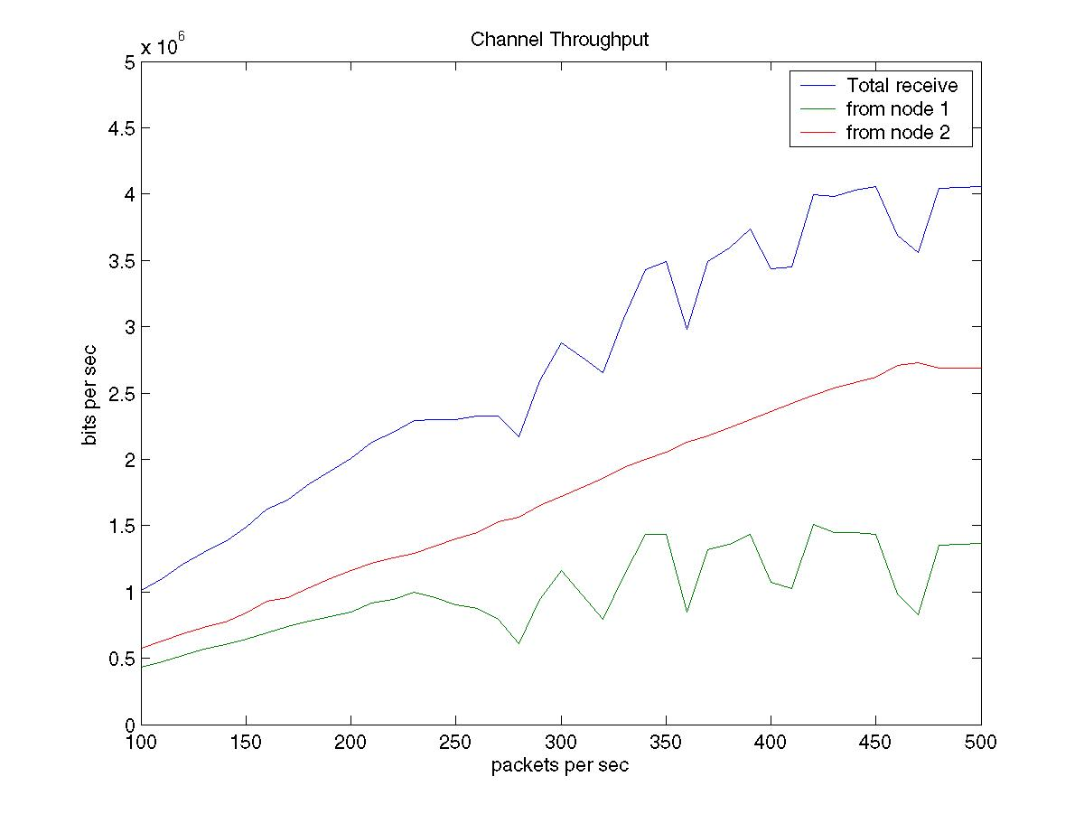
Figure 6: Channel throughput when 1-node encounter bad-link-quality, but MAC scheduling enabled

It can be seen that comparing to the previous experiment, the node with good link quality still has a good channel throughput when the other node is inflicted with low signal strength. In detail, we can see from Figure 7 that when one node is affected by bad channel quality, the other node even achieve better channel throughput then that of experiment 1. As in experiment 3, the peak value of channel throughput is 2.7Mbps whereas in experiment 1, the peak value is only 2.2Mbps. Because the node with bad link quality’s transmission request has been suppressed (ignored), it leaves more channel resource to other nodes.
Also, from figure 7, we compare the performance of the node with good link quality to that of experiment 2. It can be seen that when the link is lightly-loaded, the performance difference does not appear because although the link is somewhat wasted by the other
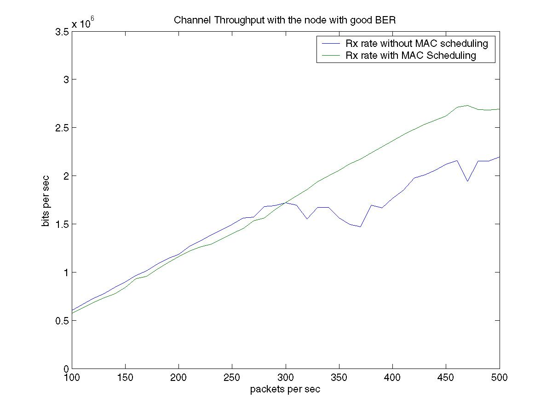

Figure 7: Channel throughput Comparison: Slave Node 1 (with good link quality)

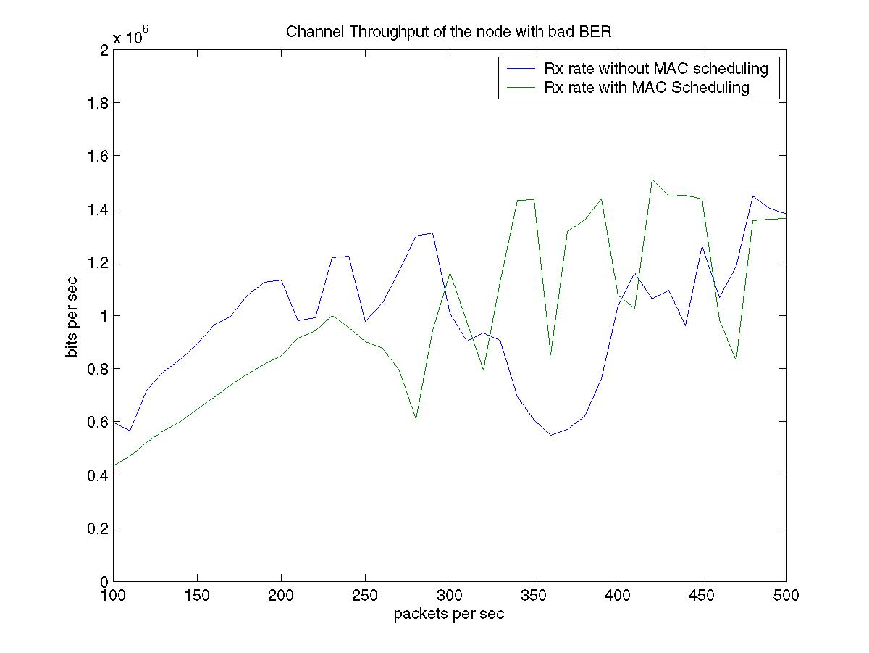

Figure 8: Channel throughput Comparison: Slave Node 2 (with bad link quality)

node, there are still enough link resource to guarantee the packet transmission in one time period.
From Figure 8, the plot compares the results of with/without MAC scheduling for the node with bad link quality. It is hard to tell the difference. The only thing can be explained is that when link is lightly load, the channel throughput is decreased when my MAC scheduling is applied. It is because some packets are dropped by the scheduling algorithm.

6 Discussion

The MAC scheduling algorithm used here is quite simple. However, it still shows that the scheduling is effective to improve performance. Actually, the scheduling algorithm adopted in the experiments is not a real “scheduler”. It discarded the packets rather than delay or arrange them for an appropriate time. In future work, experiments will be proceeded to test whether real scheduling algorithm is also providing good results. Also, the methods to determine schedule rule is also a key issue for further research.

Currently in the experiment, UDP protocol is used for the test application program. UDP use datagram sockets, which is essentially a connectionless layer 4 link. If we use TCP protocol instead, does the experiment yields the same results. This is an interesting topic.

Also, packet generation method could also be improved for future experiments. Now, packets arrival are periodical. To simulate real world network traffic, a Poisson distribution or more complex model is preferred.

7 Reference

- Bhagwat, P.; Bhattacharya, P.; Krishna, A.; Tripathi, S.K.; “Enhancing throughput over wireless LANs using channel state dependent packet scheduling” INFOCOM '96. Fifteenth Annual Joint Conference of the IEEE Computer Societies. Networking the Next Generation. Proceedings IEEE , Volume: 3 , 24-28 Mar 1996 Page(s): 1133 -1140
- Crow, B.P.; Widjaja, I.; Kim, L.G.; Sakai, P.T. “IEEE 802.11 Wireless Local Area Networks”. IEEE Communications Magazine, Vol.35. No.9, Sep 1997. page 116-126
- C. Fragouli, V. Sivaraman and M. Srivastava, "Controlled Multimedia Wireless Link Sharing via Enhanced Class-Based Queuing with Channel-State-Dependent Packet Scheduling”, in Proceedings of the Conference on Computer Communications (IEEE Infocom), (San Francisco, California), pp. 572, March/April 1998.
- Aida, H.; Tamura, Y.; Tobe, Y.; Tokuda, H.; “Wireless packet scheduling with signal-to-noise ratio monitoring” Local Computer Networks, 2000. LCN 2000. Proceedings. 25th Annual IEEE Conference on ,2000, Page(s): 32 -41
- Haiyun Luo, Songwu Lu and Vaduvur Bharghavan, “A New Model For Packet Scheduling in Multihop Wireless Networks”, ACM MOBICOM (International Conference on Mobile Computing and networking) 2000, Boston, MA, August 2000.
- Henry, P.S.; Hui Luo, “WiFi: what's next?” IEEE Communications Magazine, Vol.35. No.12, Dec 2002, page 66-72
- IEEE Standard 802.11, http://standards.ieee.org/getieee802/

